A Comparative Analysis of Voter Turnout: Baltimore City and Maryland Counties

Jiaxin Huang

Joshua Stim

03/10/2025

Executive Summary:

This study analyzes voter turnout disparities between Baltimore City and other Maryland counties, identifying demographic, educational, economic, and transportation factors that may contribute to lower participation rates in Baltimore city.

Preliminary analysis reveals that Baltimore has a higher Black population and lower White population than other counties. Educational attainment is lower, particularly at higher education levels. The city also faces higher unemployment and greater economic inequality. Transportation differences are notable, with lower rates of solo commuting and higher reliance on public transit.

Linear mixed effects models revealed that tract-level median household income and older age amongst registered voters are positively associated with registered voter turnout across election types and election years. It also highlights tract-level features that may be associated with lower registered voter turnouts, such as percent of registered voters who are male, percent who are Hispanic, percent of the tract population that is unemployed, and percent of the tract population with a high school educational attainment.

## **Introduction**

Baltimore City’s voter turnout is approximately 10% lower than the Maryland state average, with historically marginalized communities facing systemic barriers to voting. This report analyzes demographic and socio-economic differences between Baltimore and other Maryland counties to identify key factors contributing to this turnout gap.

## **Methods**

This study utilizes 2022 L2 voter file and American Community Survey (ACS) data to analyze voter turnout disparities. L2 provides census-block-level data on registered voters, including race, age, gender, and turnout for the 2020 and 2022 elections. ACS provides census-tract-level data on all residents, including median household income, educational attainment, unemployment, and public transit usage.

The outcome variable is voter turnout rate (continuous). Predictor variables include age group (categorical), race/ethnicity (categorical: White, Hispanic, African American, Asian), and gender (categorical: Male, Female, Unknown), median household income (continuous), unemployment rate (continuous), educational attainment (categorical: High School, Bachelor’s, Graduate), and transportation method (categorical: Personal Vehicle, Public Transit, Remote Work).

L2 data were aggregated to the census-tract level, and tracts missing demographic data (n = 21) or with fewer than 50 registered voters (n = 2) were excluded. The final dataset comprises 1,454 census tracts across 24 counties, integrating voter registration and socio-economic data for a comprehensive turnout analysis.

We first conducted a preliminary analysis, comparing summary statistics and utilizing data visualization to identify potential factors associated with lower voter turnout in Baltimore City. We then fit linear mixed effects models to quantify the strength and significance of these associations while accounting for spatially correlated residuals within county and repeated measures of voter turnout by census tract. We specifically used the `lme4` and `lmerTest` packages in R to fit the following model separately by election type (i.e., primary vs. general):

turnout | county, tract ~ bmore*year*(median_income + median_income_sp1 +

percent_african_american + percent_hispanic +

percent_over_65 + percent_transit +

percent_male + percent_unemployed) + 1|county/tract.

Here, *turnout* (i.e., the percentage of registered voters in a census tract that voted) was modeled as a function of each demographic variable moderated by election year and if the tract is in Baltimore city. Intercepts were allowed to vary by county and tract within county, and median household income was modeled using a linear spline with a knot at $75,000. The knot point was selected based on visual inspection of the marginal relationship between tract-level median income and registered voter turnouts. A detailed assessment of model assumptions and sensitivity to outliers is provided in the supplementary R markdown document. Overall, qq-plots indicated that model residuals were roughly normally distributed, and residual vs. fitted plots suggested that residuals were more-or-less independent of fitted values. Additionally, sensitivity analysis revealed that model fits for primary and general elections were similar after removing the 3 most influential census tracts, as determined by Cook’s distance, from the dataset.

To facilitate assessment of predictor effect sizes on registered voter turnouts, we also obtained standardized estimates from each model. These were obtained separately for primary and general elections by z-normalizing the turnout percentages as well as each of the demographic predictor variables, and then refitting the model. The R code used to obtain these standardized estimates and confidence intervals can be found in the supplementary R markdown document.

## **Results:**

Table 1 compares the means of each predictor variable in Baltimore city to the Maryland state average. Most notably, Baltimore city had a higher proportion of black registered voters and a higher proportion of the total population relying on public transportation compared to the Maryland average. Figures 1 through 6 display the Maryland census-tract-level distributions for each predictor variable by Maryland county.

Figure 7 displays the distribution of census-tract-level registered voter turnouts for each Maryland county for the 2020 and 2022 general elections. While Baltimore city had the lowest median registered voter turnouts across all Maryland counties, it also had the widest distribution of turnouts, with some census tracts in Baltimore city reporting very high turnouts, and others reporting some of the lowest turnouts in all of Maryland.

Figure 8 displays the same information as figure7, but for the 2020 and 2022 primary elections. This plot suggests that median registered voter turnouts for primary elections are similar, if not higher, in Baltimore city compared to the rest of Maryland. The height of the boxplots for Baltimore city again suggest that voter turnout is quite variable at the census tract level when comparing to other counties in Maryland.

Figure 9 is a “spaghetti plot” that allows us to visualize how registered voter turnouts in Maryland change *within* a census tract from 2020 to 2022 for general and primary elections. While most census tracts reported a decrease in turnout from 2020 to 2022 for both election types, the rate of decrease is not constant across census tracts. In fact, a small subset of census tracts reported a slight increase in registered voter turnouts from the 2020 to 2022 primary elections.

Figure 10 displays the spatial distribution of registered voter turnouts for census tracts in Baltimore city, as well as the *percent change* in turnouts from 2020 to 2022. The observed spatial trends highlight the fact that registered voter turnouts at the tract level are quite heterogenous within Baltimore city and are likely influenced by racial and socio-economic boundaries. A key takeaway from these maps is that tracts with the lowest turnouts in 2020 elections also reported the greatest *percent decrease* in turnouts from 2020 to 2022. This pattern is consistent across primary and general elections.

Tables 2a and 2b summarize the fixed effects models for general and primary elections, respectively. For general elections, we can see that tract-level median household income among the total population (not just registered voters) has a greater positive effect on registered voter turnout in tracts with median incomes between $0 and $75,000 compared to tracts with median incomes over $75,000. That is, for the general 2020 election within tracts with median incomes between $0 and $75,000, a $10,000 increase in median household income was associated with an expected turnout increase of 3.43 percentage points (95% CI: 3.07, 3.78) in greater Maryland and an expected turnout increase of 2.96 percentage points (95% CI: 2.40, 3.51) in Baltimore city, controlling for the other predictors. On the other hand, for the general 2020 election within tracts with median household incomes over $75,000, a $10,000 increase in median household income was associated with an expected turnout increase of 0.54 percentage points (95% CI: 0.45, 0.64) in greater Maryland, and 0.68 percentage points (95% CI: 0.31, 1.04) in Baltimore city, controlling for the other predictors. Similar estimates were obtained for the 2022 general election and both primary elections. Aside from median income, percent of registered voters over 65 years old was positively associated with registered voter turnout at the tract-level for both primary and general elections, while percent of registered voters who are Hispanic, percent of registered voters who are male, percent of the tract population that is unemployed, and percent of the tract population with a high school educational attainment were mostly negatively associated with registered voter turnouts for primary and general elections.

While predictor effects on voter turnout were mostly similar between Baltimore city and greater Maryland, the effect of percent of registered voters who are Hispanic was significantly more negative for Baltimore city compared to the rest of Maryland across election years and election type. For instance, for the primary 2020 election, a 10 percentage point increase in percent of registered voters who were Hispanic was associated with a 1.28 percentage point *decrease* (95% CI: -1.70, -0.86) in registered voter turnout among tracts *outside* of Baltimore city, but a 9.64 percentage point decrease (95% CI: -12.29, -6.98) in turnouts among tracts *in* Baltimore city.

While the directionality of predictor effects on voter turnout was mostly consistent across election year and election type, the effect of percent of registered voters who are African American appeared sensitive to election type and census tract location (i.e., in Baltimore city vs. greater Maryland. For instance, in the 2020 elections *outside* of Baltimore city, a 10 percentage point increase in the percent of registered voters who were African American was associated with virtually no change in expected tract-level voter turnout for the general election (Estimate, 95% CI: -0.08 [-0.24, 0.09]), but was associated with a 1.47 percentage point *increase* (95% CI: 1.32, 1.62) in tract-level voter turnout for the primary election.

Finally, figures 11 and 12 display the standardized estimates (i.e., effect sizes) of each predictor on registered voter turnouts by election year, election type, and tract location (i.e., Baltimore city vs. greater Maryland). These standardized estimates mirror the unstandardized estimates in terms of significance and directionality, but they allow the reader to determine which predictors had the largest or smallest effects on voter turnouts.

## **Conclusion:**

Baltimore City has a significantly higher Black population (63.1%) and a lower White population (25.1%) than the state average (28.9% and 49.8%, respectively). Lower educational attainment at higher education levels suggests potential barriers to political engagement. Economically, Baltimore City experiences higher unemployment (6.9%) than the state average (5.1%). Transportation access further differentiates Baltimore City from the rest of the state. Residents are less likely to drive alone to work (65.2%) compared to the state average (76.0%) and rely more on public transit (12.8%) than the statewide rate (5.5%). These differences may contribute to disparities in polling place accessibility and convenience, further influencing voter participation.

The descriptive analysis of voter turnouts, as presented in figures 7 through 10, demonstrated the degree to which registered voter turnouts can vary both within and across Maryland counties. We saw that while Baltimore city had the lowest median turnouts for 2020 and 2022 general elections across all Maryland counties, the range of turnouts within Baltimore city was wide, encompassing some of the highest and lowest turnouts in all of Maryland. The tract-level map of voter turnouts in Baltimore city showed how this variability was distributed across the city, and suggested that voter turnouts may follow spatial patterns of segregation and social inequities.

The linear mixed effects models allowed us to quantify the effects of tract-level demographic variables on registered voter turnouts across election types, election years, and census tract location, all while controlling for potential confounding. We found that median household income and older age in registered voters within a census tract were both positively associated with voter turnouts across election types and years. We also found that percent of registered voters who are Hispanic, percent of registered voters who are male, percent of the tract population that is unemployed, and percent of the tract population with a high school educational attainment were mostly negatively associated with registered voter turnouts for primary and general elections. Additionally, we found that the percent of registered voters who are Hispanic had a significantly more negative impact on voter turnouts in Baltimore city compared to the rest of Maryland across election years and types. The reason for this difference remains unclear and may be due to a variety of factors such as differences in voter engagement and the presence of social inequities. Therefore, it is important to emphasize that while the current analysis identifies tract-level features that may explain voter-turnout-variability across Maryland and Baltimore city, it does not explain *why* these predictors are associated with higher or lower turnouts. To address these questions, future analyses should implement community-level qualitative surveys to explain why certain features, such as the socioeconomic and racial/ethnic composition of registered voters within a census tract, are particularly influential in predicting registered voter turnouts at the tract level.

## **Tables and Figures:**

Figure 1: Gender distribution by County in Maryland State (Pink is Baltimore City)

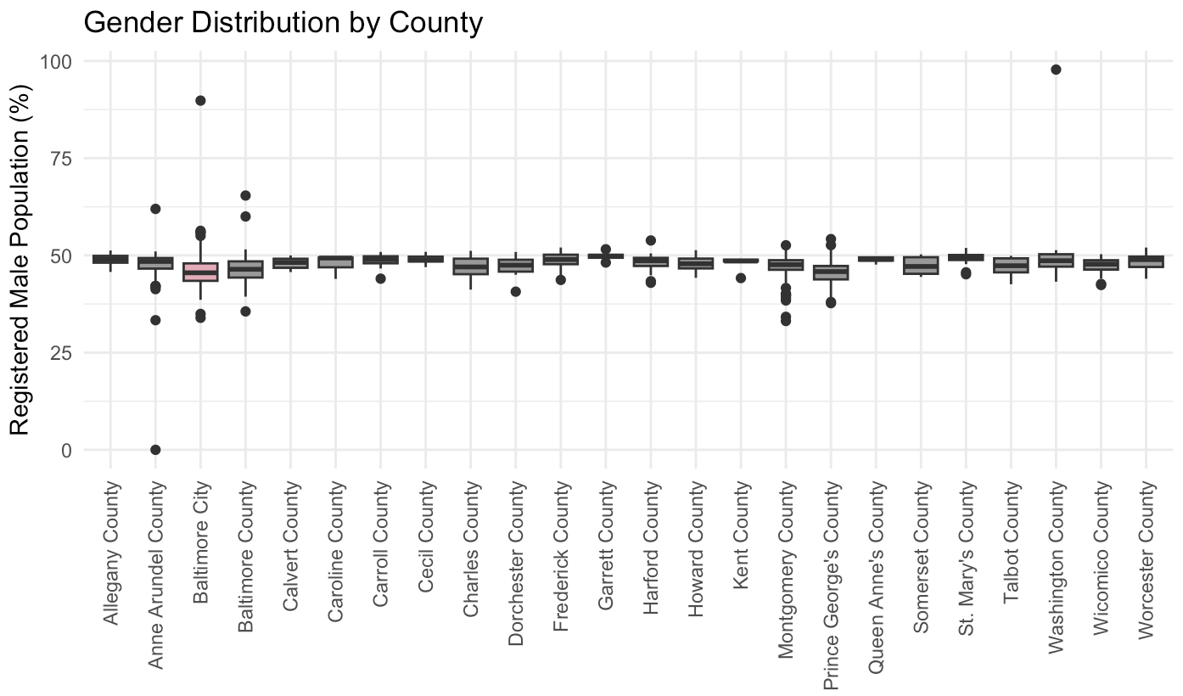

Figure 2: Race distribution by County in Maryland State (Pink is Baltimore City)

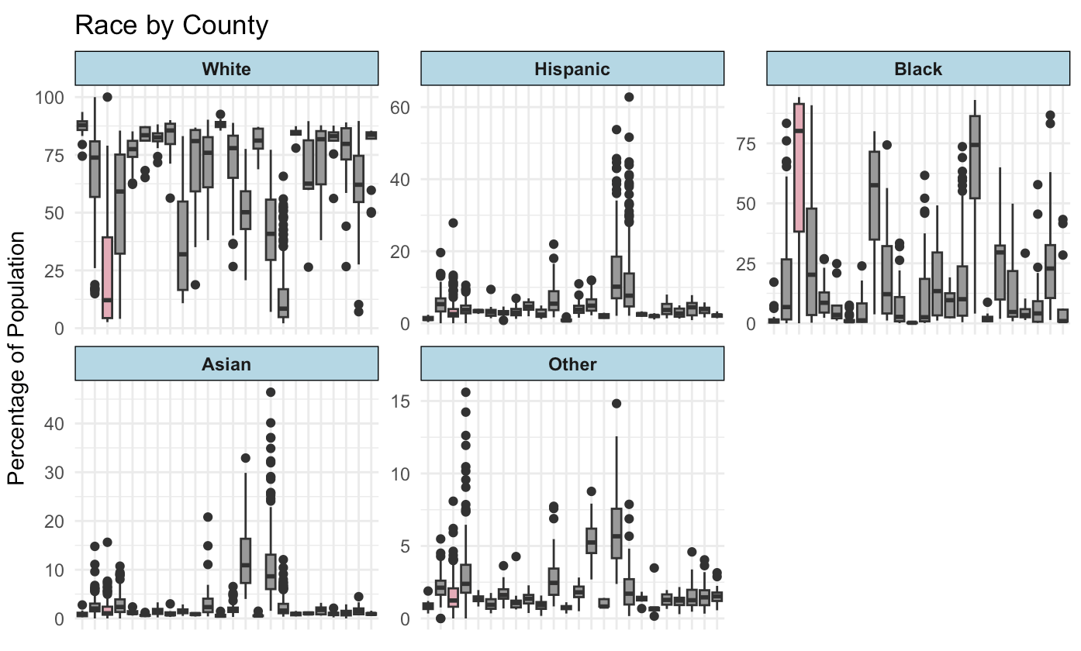

Figure 3: Unemployment rate distribution by County in Maryland State (Pink is Baltimore City)

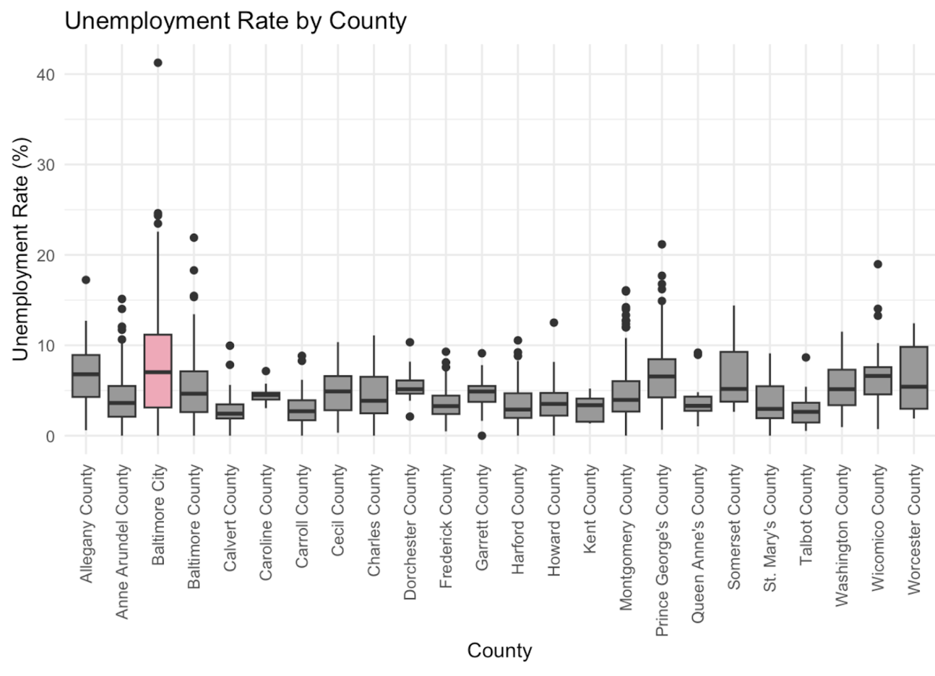

Figure 4: Median household income by County in Maryland State (Pink is Baltimore City)

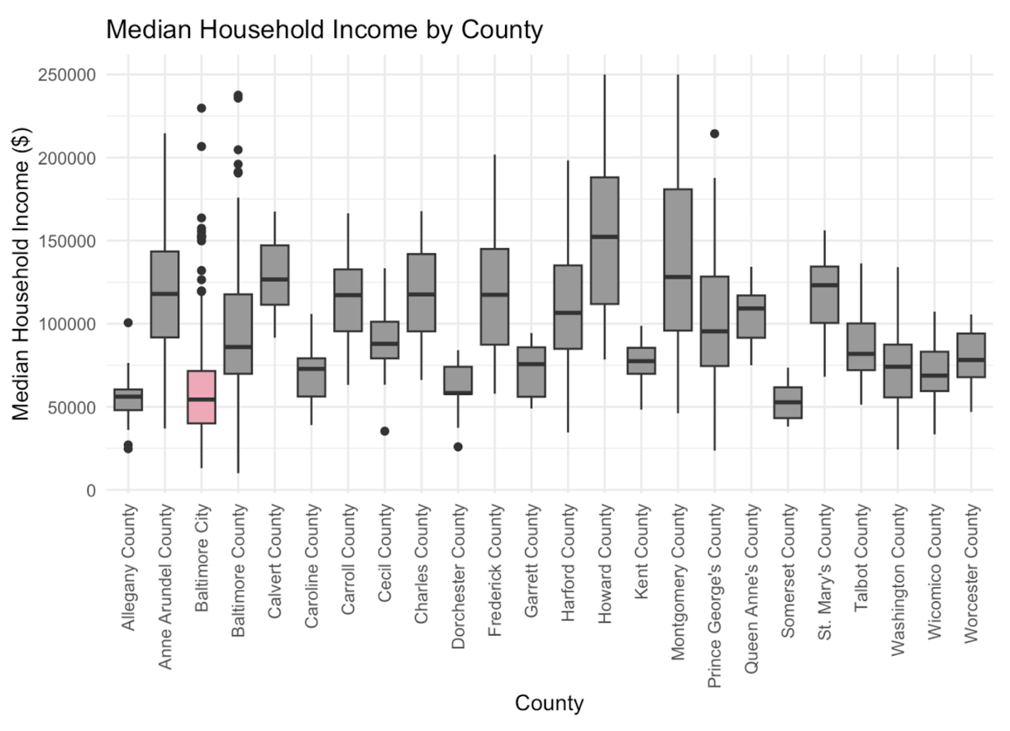

Figure 5: Education attainment by County in Maryland State (Pink is Baltimore City)

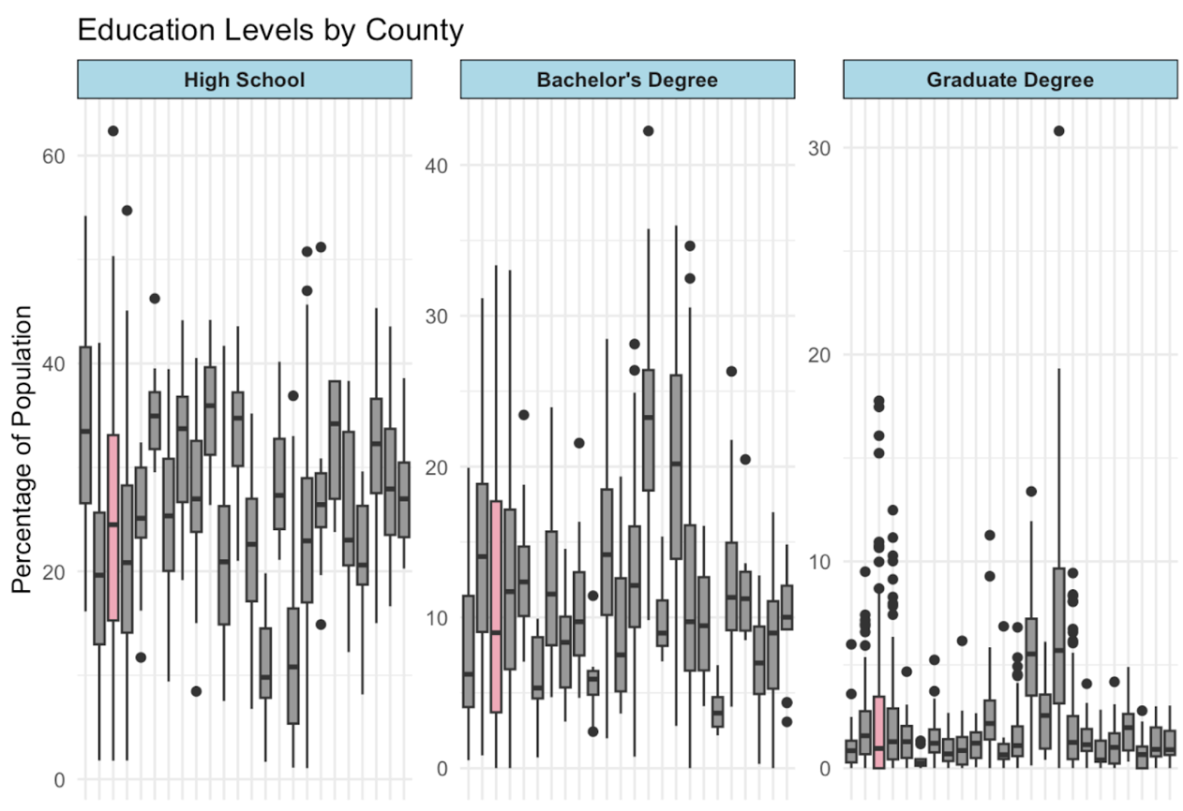

Figure 6: Transportation method by County in Maryland State (Pink is Baltimore City)

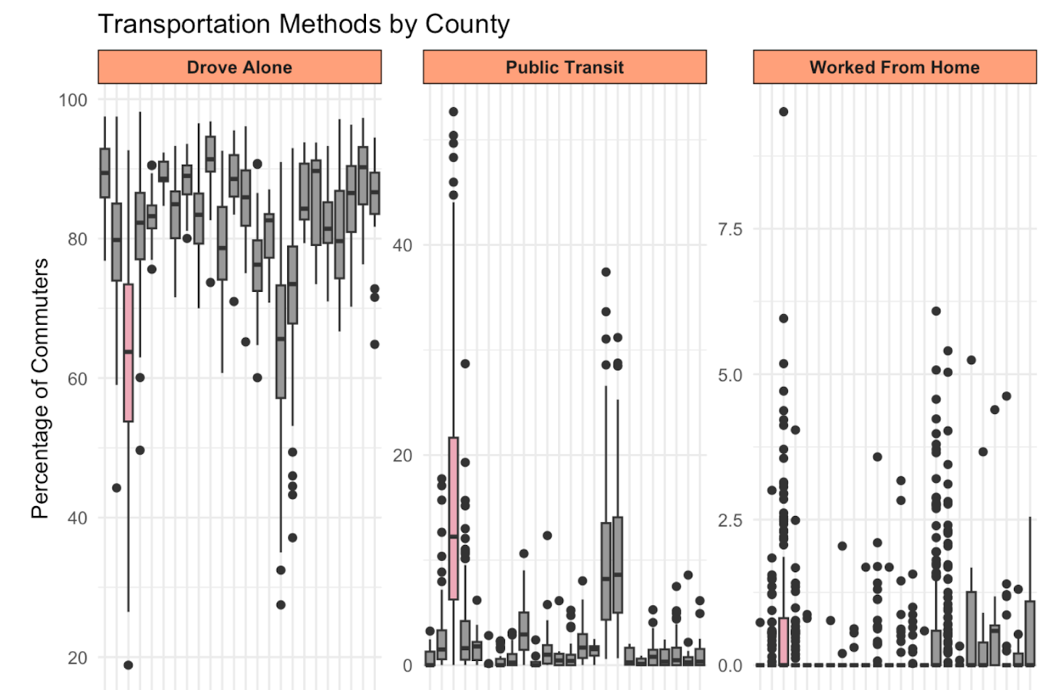

Figure 7. County-level turnout for 2020/2022 Maryland general elections

Figure 8. County-level turnout for the 2020/2022 Maryland primary elections

Figure 9. Census-tract-level change in registered voter turnout from 2020 to 2022 for Maryland general and primary elections

Figure 10. Census-tract-level registered voter turnout and percent change in registered voter turnout from 2020 to 2022 for general and primary elections in Baltimore City

Table 2a: Unstandardized adjusted estimates and 95% confidence intervals for general elections

Table 2b: Unstandardized adjusted estimates and 95% confidence intervals for primary elections

Figure 11: Adjusted standardized estimates for 2020/2022 general elections

## Figure 12: Adjusted standardized estimates for 2020/2022 primary elections

